1 Certification Conditions for SN Registrars offices and Agents including Member Certification bodies QEC & DAS & SNR Certification.

1.1 Introduction
The purpose of this document is to detail the rules for SN Registrars and to ensure all members including QEC & DAS & SNR understand the process.The company that is accredited by UKAS is SN Registrars (Holdings) Ltd trading as QEC Certification & DAS Certification & SNR Certification, and all the Agents/offices and partners for the conditions for the use of marks/logos and the company names of the Agents/offices and partners. This is to clearly define to all interested parties that UKAS has only accredited SN Registrars (Holdings) Limited trading as QEC & DAS & SNR Certification and that the Agents/offices and partners operate through agreement and approval as the Agent/office or partner of SN Registrars.

All SN Registrars trading as QEC & DAS & SNR Certification Agents/offices and partners shall comply with the following conditions governing the use of the Certificate of Approval and mark/symbol of the Certification Body. There are separate logos for QEC & DAS & SNR Certification but all logos will clearly state “Members of SN Registrars (Holdings) Ltd” and have the UKAS number.

  - Use of SN Registrars mark and UKAS Logo on certificates

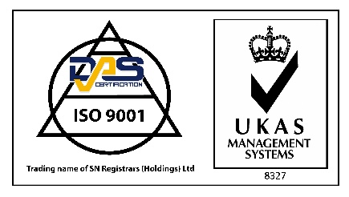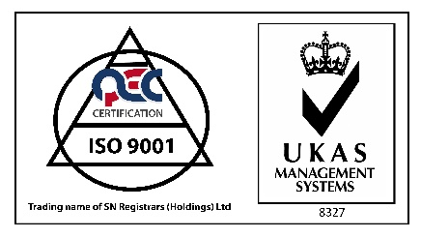
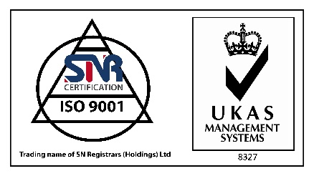

a) The above SN Registrars mark and UKAS logo shall only be displayed together on all issued certification certificates. The mark and logo shall always be used in conjunction with the Client's name and have the certificate number adjacent to it.
(b) The mark may be reproduced in any size or single colour provided the configuration is strictly adhered to, including the surrounding frame.
(c) The mark may be used on stationery, such as headed letter paper and advertising brochures, and only in connection with the International Quality System Standard scope of supply listed on the certificate.
(d) The mark shall not be used on flags, buildings, vehicles, packaging, directly on products, nor on promotional products such as calendars, diaries, coasters, etc.
(e) The mark shall not be used in any way to imply product approval, or on documentation such as test certificates and certificates of conformity.
(f) The certificated Client shall, upon reasonable notice, discontinue any use of the mark which is considered to be unacceptable to the Certification Body.
(g) Upon termination of the certification, for whatever reason, the Client shall discontinue all use of the mark immediately.

1.4 Use of the SN Registrars Mark and UKAS logo for use on Certification Body communications and documentation
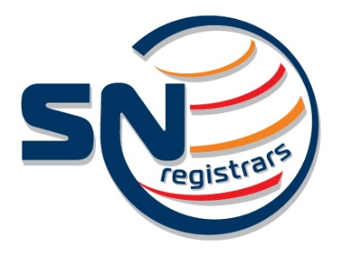

The above mark and UKAS logo is to be used only on SN Registrars Head Office.

Use of the SN Registrars name with Agent/office or partners Company Names.

A clear indication shall be presented to all interested parties that the UKAS accredited certification body is SN Registrars.

Where the Agent/office or partners Company name is used in conjunction with the UKAS logo then on documentation, web site or for a certification activity on behalf of SN Registrars then the Agent/office or partners Company name shall be presented to clearly identify that SN Registrars is the UKAS accredited company. See examples below:

Shanghai DAS Certification Co., Ltd.
“Member of SN Registrars (Holdings) Limited” – UKAS Accreditation 8327

SNR Certification (UK) Ltd.
“Member of SN Registrars (Holdings) Limited” – UKAS Accreditation 8327

QEC Gulf
“Member of SN Registrars (Holdings) Limited” – UKAS Accreditation 8327

